  Dr. N. REKHA  M.Sc (Bot)., M.Ed., M.Phil., M.A (Soc)., M.Sc (Psy)., SET (Edn)., Ph.D (Edn).,  Principal cum Professor  email: jenneyseducation@gmail.com  Mobile: 6369838741, 9940711555 | 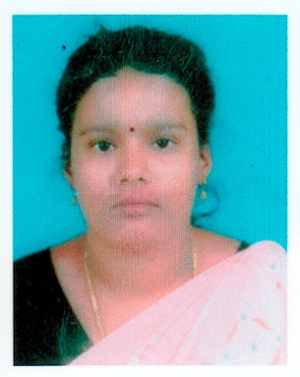  Ms. K. NISHANTHI  M.Sc., M.Ed.,  Assistant Professor in Perspectives in Education
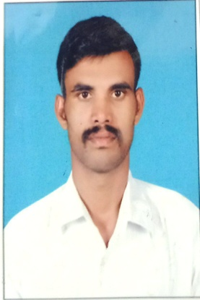  Mr. D. MANIVASAGAN  M.Sc., M.Ed.,  Assistant Professor in Perspectives in Education | 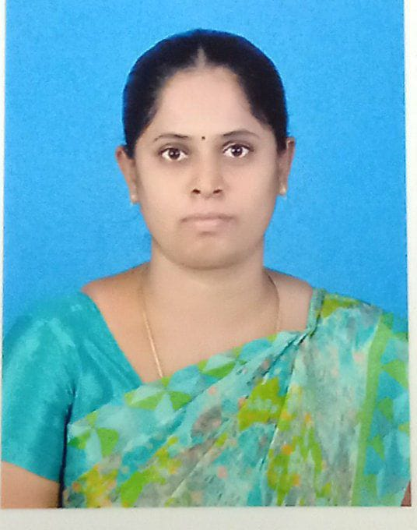  Ms. K. PRIYA  M.A., M.Ed., M.Phil.,  Assistant Professor in Perspectives in Education
Mr.R. BALAMURUGAN  M.Sc., M.Ed., NET (Edn).,  Assistant Professor in Perspectives in Education | 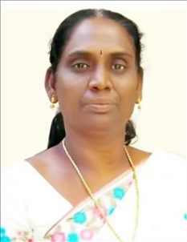  Ms. J. JOSEPHINE B.Lit.,M.A(Tamil).,M.Ed.,M.Phil  Assistant Professor in Tamil
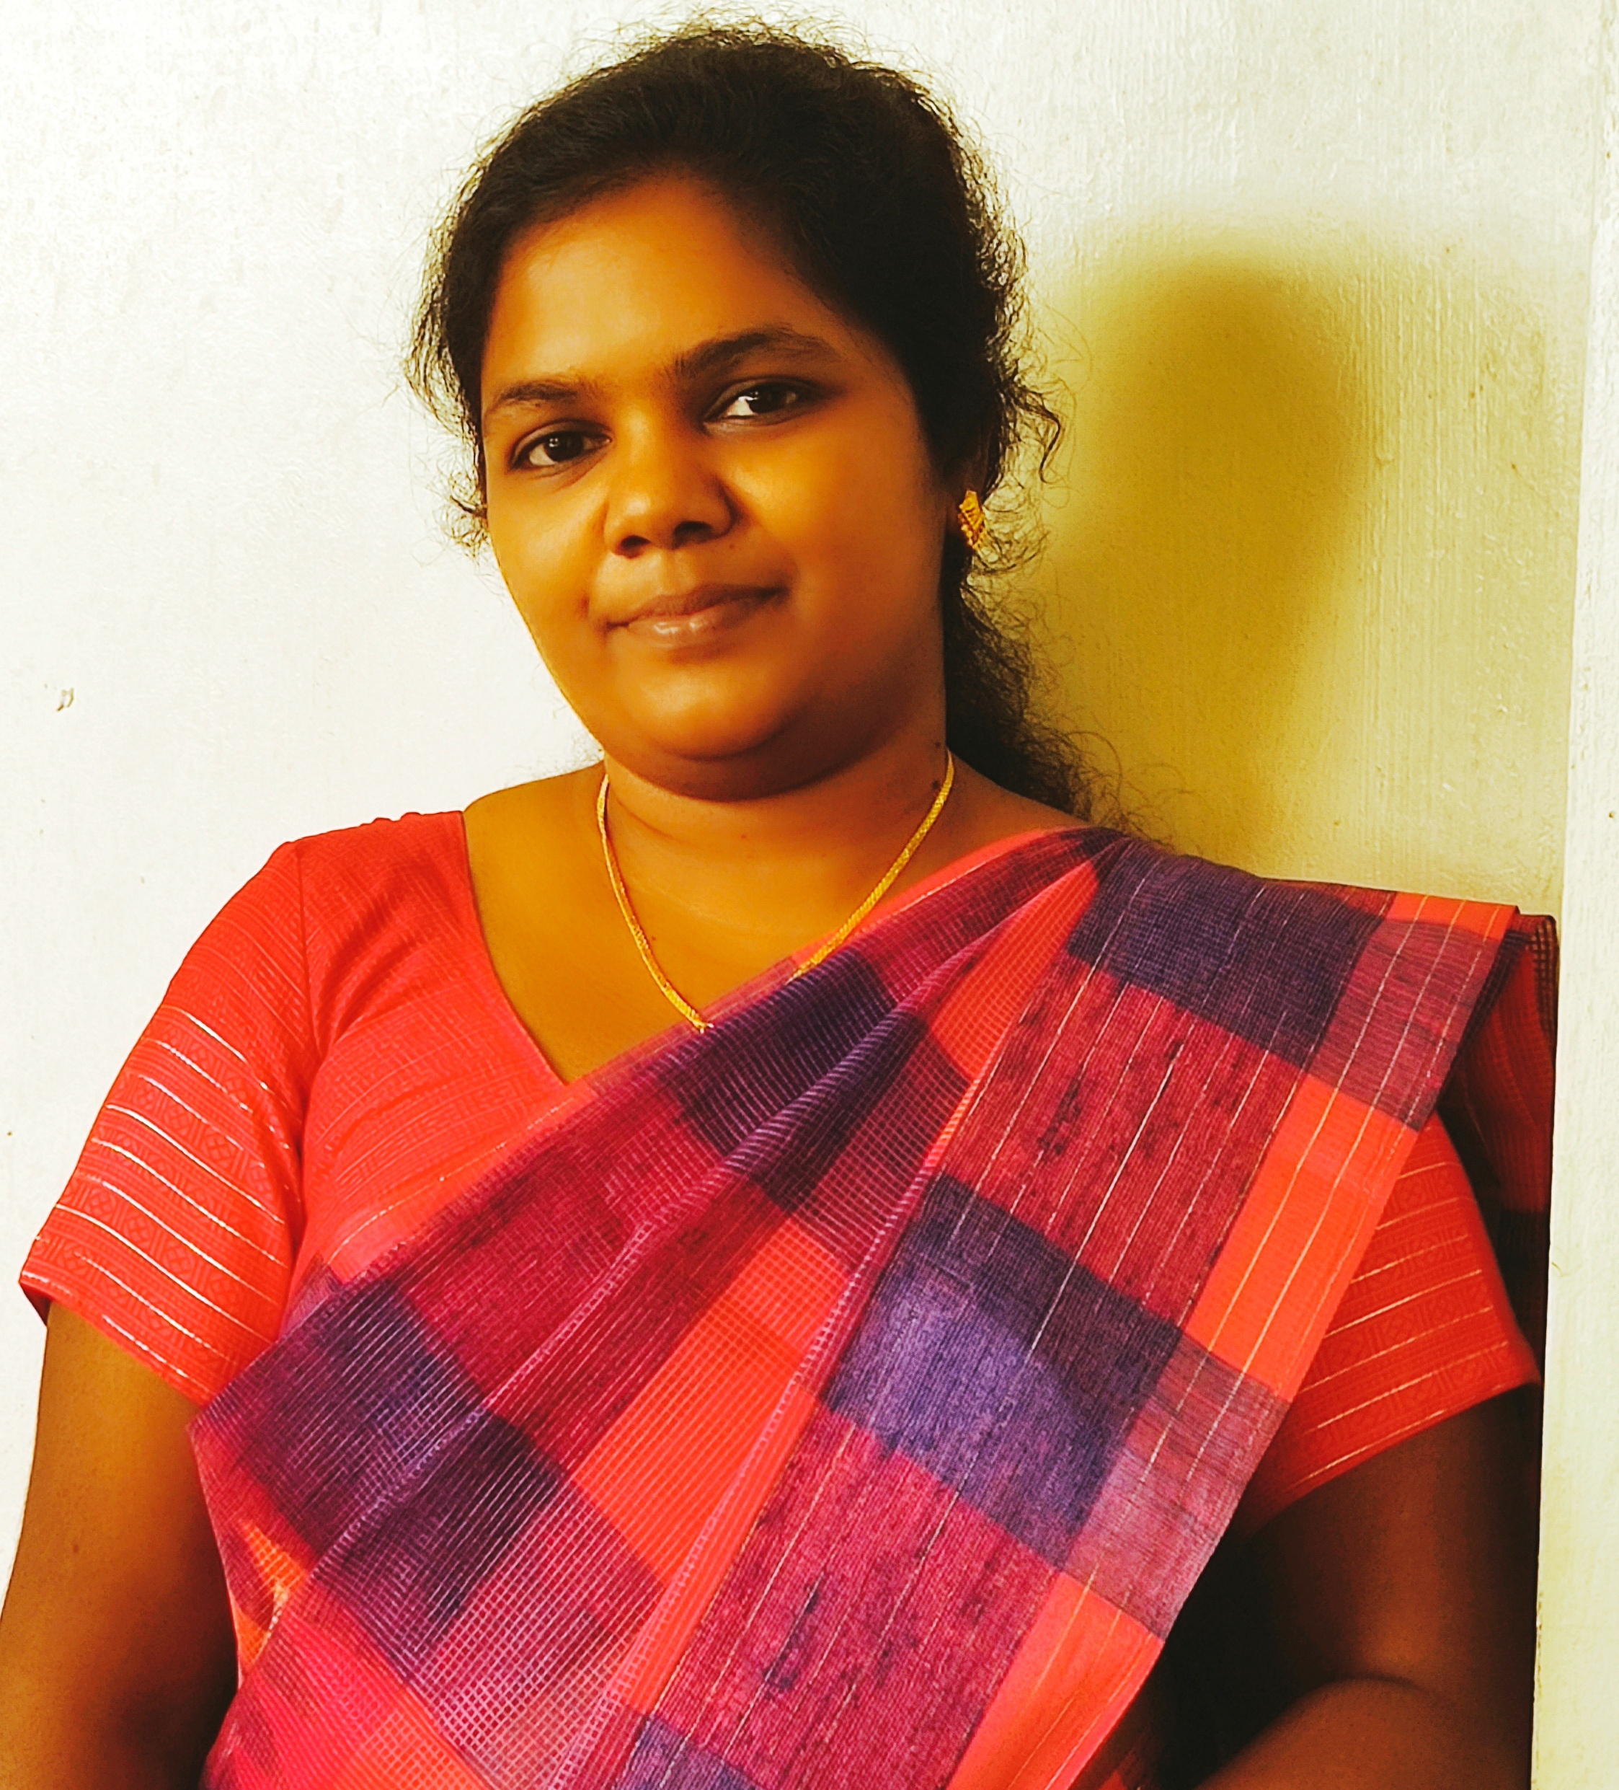  Dr. V. JELSIA JABAMANI  M.A(Eng).,M.Ed.,M.Phil.,M.A(Soc)., SET(Edn.&Eng),NET-JRF, Ph.D(Edn.)  Assistant Professor of English | 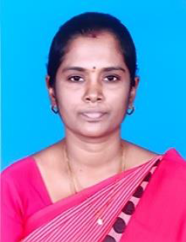  Ms.P.SIVAKAMI  M.Sc(Maths).,M.Ed.,M.Phil(Maths)  Assistant Professor in Mathematics
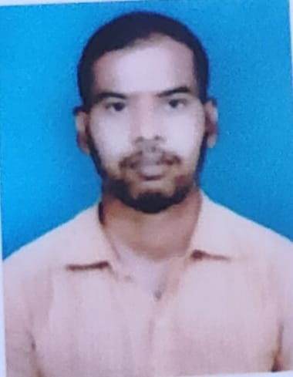  Mr. POTULA RAVEENDRA  M.Sc., M.Ed., SET (Edn).,  Assistant Professor in Physical Science | 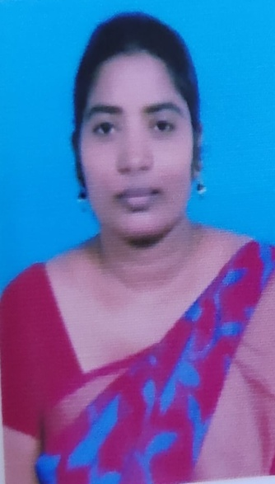  Dr. P. REVATHI  M.Sc., M.Ed., Ph.D (Edn).,  Assistant Professor in Biological Science
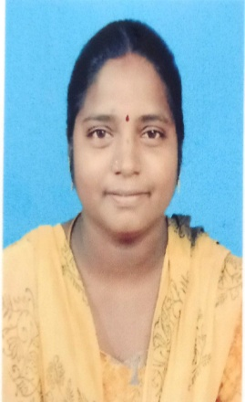  Ms. D. MALATHI  M.A., M.Ed.,  Assistant Professor in History | 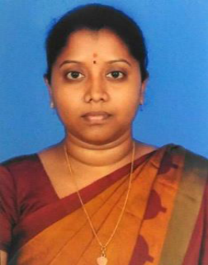  Ms.P.PRIYA  MCA.,M.Ed.,M.Phil(Edn.)  Assistant Professor in Computer Science
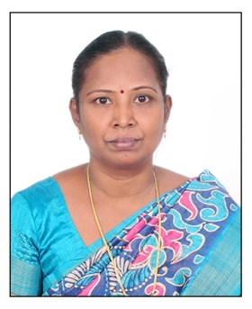  Ms.S.AROCKIA MARY RANI  M.Com.,M.Ed.,M.A(Edn).,M.Phil(Edn.)  M.Phil(Commerce)  Assistant Professor in Commerce |   Ms. B. SANGEETHA  M.Sc., M.F.A.,  Assistant Professor in Fine Arts


Ms. V. VAILA JENEEFER
M.F.A.,
Assistant Professor in Performing Arts

